Week 9 Workbook | Google My Business Checklist

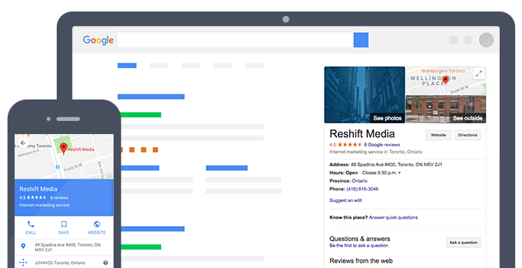

- Claim your Business Profile
- Complete every section of your Google My Business account
- Be meticulous with contact information
- Select primary and secondary categories
- Mark off applicable attributes
- Write a complete “from the business” description
- Publish Google posts weekly
- Upload new photos weekly
- Answer questions
- Collect and respond to reviews
- Add your products and/or services
- Set up messaging
- Maintain your Business Profile

