Week 8 Workbook | On-Page SEO Checklist

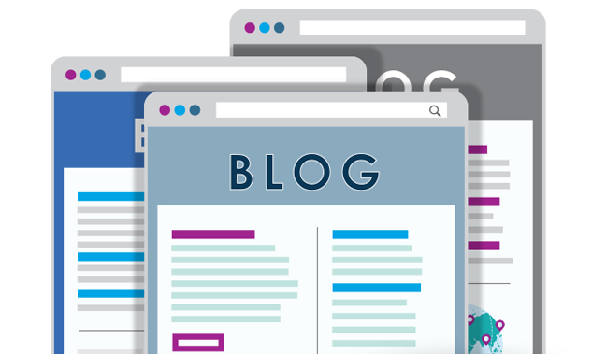

Before you publish
☑ Do you have a killer headline that generates an appetite to read more and a promise that the reader will get value?

☑ Are you creating content that is answering a burning question or solving a problem?

☑ Will people leave the blog post with actionable knowledge and key takeaways?

☑ Is your opening paragraph compelling and challenge your reader that they need to read on to learn more?

☑ Do you have engaging images, videos, quotes, tweetables to keep your audience interested?

☑ Is your SEO title is under 70 characters?

☑ Do you have meta description included?

☑ Is your focus keyword in your title, description, and post content?

☑ Is your post URL relevant and short?

☑ Do you have related keyword variations in your article?

☑ Are you interlinking your blog posts?

☑ Make sure all external links open in a new window.

☑ Add proper image credits and sources.

☑ Is your featured image sized appropriately for social sharing (1200 px wide by 630 px tall)

☑ Do your images have alt tags, filenames and descriptions?

☑ Check post thumbnail for proper social media dimensions.

☑ Does your post have short paragraphs, bullet points, sub-headers for ease of reading?

☑ Do you have proper sections (h2 for sub-headings, h3 for paragraph titles, lists,)?

☑ Check for call-to-actions.

☑ Post contains at least one tweetable

☑ Add categories and tags.

☑ Preview post for spelling and grammatical errors and test how it looks on the live site.

After you publish

- Re-read and revise

- Share it on your social profiles

- Send it to your contacts in your email newsletter

- Share it to groups/communities (LinkedIn, Google+, Facebook, industry-specific)

- Link from old posts that still generate traffic

- Reply to comments

- Outreach to third party websites, blogs, partners, affiliates, industry groups for syndication (offer to write a new intro for their website)

- Re-purpose into other formats e.g. podcast, live video, animated video, eBook, checklist, webinar, online course, infographic, Slideshare presentation or a downloadable PDF.

- Schedule future social sharing.

- Measure blog performance using your analytics tools.

