Module 2 Workbook | Content Marketing

Content marketing for my business / organisation

Write down your content marketing goals from this list:

- Build brand awareness
- Discoverability (searching with intent)
- Trust
- Qualify your audience
- Position yourself as an authority voice / expert
- Generate leads
- Convert sales
- Build loyalty / increase lifetime value of customer
- Useful resource / value-add to customer / citizen
- Other, please add

1.
2.
3.
4.
5.

Prepare your target audiences based on this model below

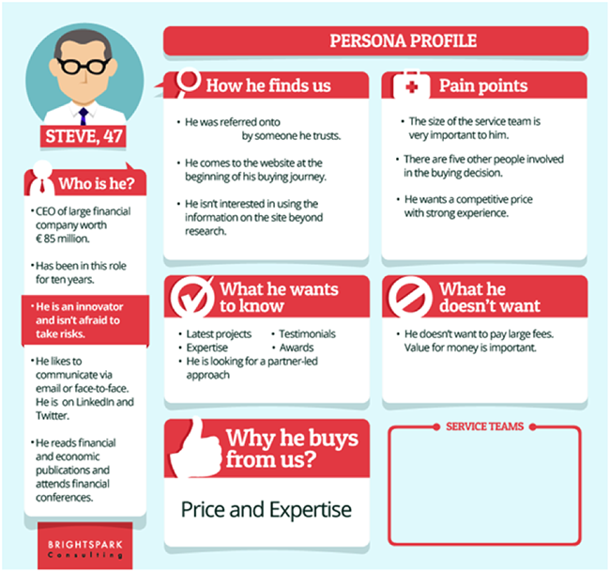

Audience 1

Audience 2

Audience 2

Write down what types of content marketing you are currently engaged in and/or would like to develop during this course and introduce into your marketing plan in 2021.

Social media marketing
- Email marketing
- Blogging
- Video marketing
- Livestreaming
- Podcasting
- Downloads
- Webinars
- eBooks
- Books
- White papers/reports
- Presentations
- Other

Content to engage target audiences

Brainstorm the messages and content you will create to bring your audiences down the digital marketing funnel.

Build out your ideal audiences and think about what messages would resonate with them to take them through the funnel from awareness, to engagement and conversion = know, like, trust, want to do business/engage with you.

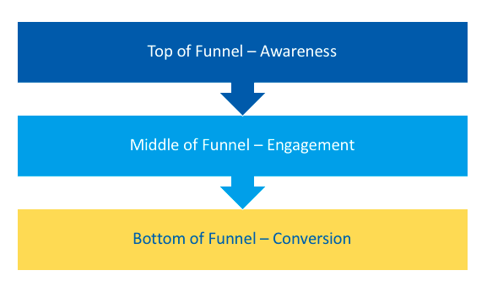

Audience Name | Content Funnel
Describe Audience 1 – give them a name! | - Awareness  - Engagement  - Conversion
Describe Audience 2 – give them a name! | - Awareness  - Engagement  - Conversion
Describe Audience 3 – give them a name! | - Awareness  - Engagement  - Conversion
Describe Audience 4 – give them a name! | - Awareness  - Engagement  - Conversion
Describe Audience 5 – give them a name! | - Awareness  - Engagement  - Conversion

Think about what content you will create to drive sales/conversion.

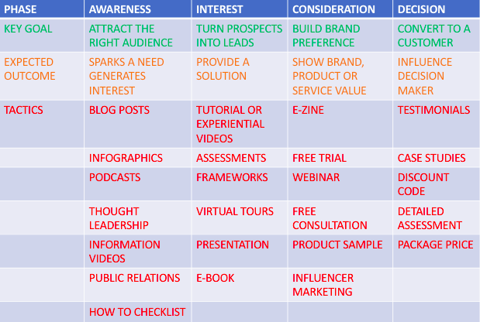

Content Plan

Use the template in the Learning Hub to develop your 12-month calendar – see my sample below.

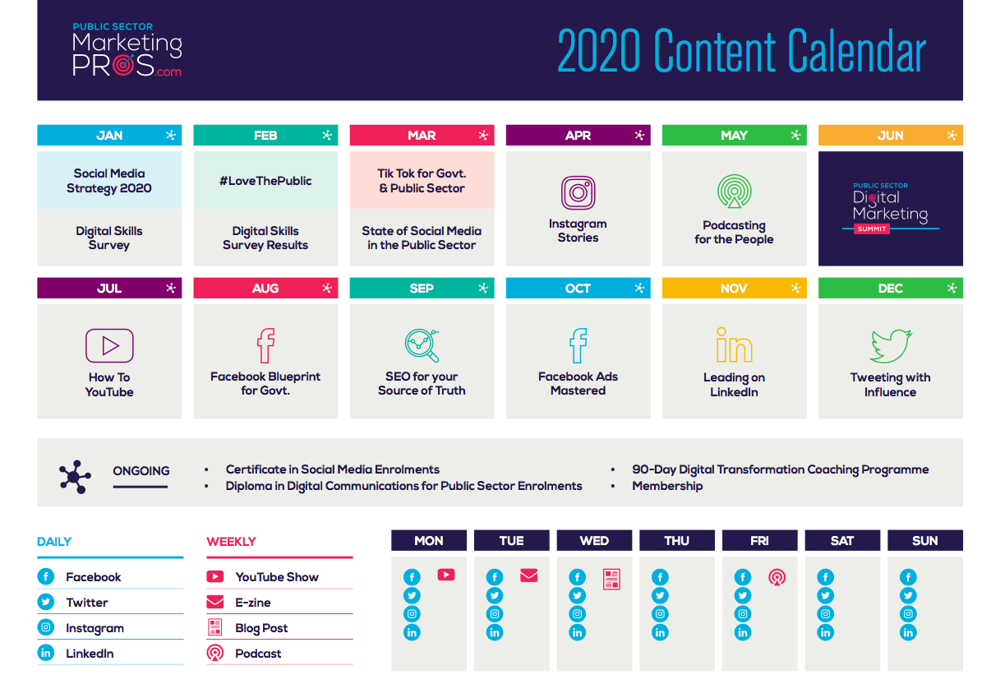

Step 1: content planning

- 12 -month calendar
- 12 pillar messages
- 4 sub-topics per pillar message
- Content format
- Content journey i.e. awareness, interest, consideration, decision

Step 2: content creation plan
- Video
- Audio
- Text
- Graphics

Step 3: content process and tools

- Video
- Audio
- Text
- Graphics

We will master content re-purposing in week 3

