

[Insert Organisation Name]
Digital Marketing Strategy
2021-2022

Table of Contents

Executive Summary 3
Mission and Vision 4
Goals and Key Performance Indicators 5
Audience Segmentation & Customer Journeys 8
Social Media 10
Social Media Metrics Benchmark 10
Website Marketing 11
On-Page SEO 11
Off-Page SEO 13
Google Analytics 14
Content Planning 15
Monthly Content Calendar 17
Weekly Content Calendar 18
Channel Strategies 18
Community Management 19
PPC advertising (Google and Facebook/Instagram) 20
Budgets and Targets 20
Facebook Ads Planner 21
List Building and Email Marketing 22
Marketing Automation & Scalability 24
Metrics and Results 27
Strategy Sign-Off and Iteration 28

Text in yellow indicates you need to customise to suit your own business/organisation
Text in blue indicates you need to refer to my notes

Executive Summary

This digital marketing strategy for [business / organisation name] will help us achieve our business goals over the next 18-months. This plan provides a practical roadmap for the transformation from traditional to digital-first marketing communications.

Our organisation requires us/me to be online to reach our core customers and stakeholders. COVID-19 has disrupted our business model and so this plan provides for a new way of working while reaching existing customers and influential audiences.

Our organisation has been operating for X years and provides [insert description of product our service] to [insert customer/audience persona/a]. Our current method of marketing relies on [insert details of how you are currently marketing your business and be honest]

The team comprises [insert who works with you, if any, and outline their roles and responsibilities briefly].

The plan covers 10 core areas:

- Goals and KPIs
- Audience segmentation and customer journey
- Content planning
- Social media marketing
- Website marketing
- PPC advertising
- List building and email marketing
- Marketing automation and scalability
- Metrics and results
- Iteration and review

We have designed our strategy with implementation in mind. So, each section includes a process for seamless implementation. Therefore, I/we will refer to it weekly / monthly. We will leverage the support of our Local Enterprise Office and other business supports to help fund any gaps in our digital infrastructure or skills.

I/We believe the success of this plan will centre on testing and iterating i.e. taking action and learning from the results.

Mission and Vision

Putting the why into our strategy provides the north star for everything we do

Vision

A vision statement is a short description of a business or organisation’s aspirations and the wider impact it aims to create. It should be a guiding beacon which underpins decision-making and determines the intended direction of the organisation.

[Insert vision here]

Mission

A mission statement is a short summary of a business or organisation’s core purpose, focus, and aims. This usually includes a brief description of what the organisation does and its key objectives.

[Insert mission here]

The mission is the “what” and the “how,” and the vision is the “why.”

EXAMPLE: IKEA

Mission statement: Offer a wide range of well-designed, functional home furnishing products at prices so low that as many people as possible will be able to afford them.

Vision statement: To create a better everyday life for many people.

Goals and Key Performance Indicators

In order to re-engineer success, we are setting out priority goals that have corresponding key performance indicators (KPIs). This will allow us to monitor and measure success with all of our digital marketing activities each month. In the matrix below, we also set out how to measure success.

*Please edit the goals and KPIs relevant to your business or organisation, these are examples, some of which may/may not be relevant.

Goals | How to measure success | KPIs
Increased revenue/profit | Increase in customers  Increase in customer value | Monthly sales targets
Increased awareness of our brand | Increased website traffic  Increased social media reach | +15% (200 unique sessions a month)  +10%
Building trust in our products/ services | Achieving industry benchmark engagement rates across our social networks  Achieving positive reviews, ratings and recommendations on our digital channels | Reach/impressions  Hashtag impact  Website traffic  Video views / retention rate (view through rate)  Engagement Rate  - Twitter 0.5%  - Instagram 1%  - Facebook 0.5%  - LinkedIn 1%  10 LinkedIn recommendations  15 Google Reviews  Avg 4/5* Facebook Reviews  Avg 4/5* Trip Advisor Reviews
Lead generation | Increasing our email marketing list month on month  Converting website and social media traffic into potential customers | +10% subscribers to our digital newsletter monthly  [insert number this represents]  Achieving a 5% conversion rate from website traffic to e-zine sign-ups / lead magnets per month  [insert number this represents]
Develop new collaborations / partnerships | Achieve new affiliate / resellers / partners with an audience we want to sell to | [Insert number] of partners / collaborators per quarter / year
Improved online thought leadership footprint | New thought leadership / expert content plan and calendar | 5,000 Podcast listens/subscribers  +25% E-zine subscribers  1,000 Webinar sign-ups  +15% Website traffic
Increased impact in our sector | Improved digital metrics | Average increase of +15% across all channels  7 media interviews (traditional media, online media, guest podcasts, guest blogs)
Sales | [List products/services] | [Insert number] product sales [List products] per month
Development of streamlined digital marketing processes | Scaled digital marketing activities within the business/organisation by leveraging tools, apps and software and improving our processes | Monthly content planning  Use of software for marketing tasks  New Standard Operating Procedures (SOPs) for digital marketing tasks e.g. video creation, editing, promoting
Scaling digital marketing skills | Digital skills training plan | Quarterly training calendar for digital marketing and social media topics
Funding and business support | Investigate supports available to develop our digital marketing capabilities | Identify supports required for each quarter of the plan and organisations providing funding/training support

Audience Segmentation & Customer Journeys

Our [busines/organisation] has a number of [customer/audience] personas.

Persona #1 (with example)
- Age: 24-34
- Gender: Female
- Location: UK
- Interests/Behaviour: Long weekend getaways, Netflix, fashion, beauty, online shopping
- Personal (marital status/job title/industry): single, engaged, married, employed, self-employed
- Pillar Message & Product: I need to revive my life! 4-day Yoga Retreat
- Content Format: Video, Podcast, Blog Post, Reviews, Stories
- Digital Channels: Website, Podcast, Instagram, Facebook

Persona #2
- Age:
- Gender:
- Location:
- Interests/Behaviour:
- Personal (marital status/job title/industry):
- Pillar Message & Product:
- Content Format:
- Digital Channels:

Persona #3
- Age:
- Gender:
- Location:
- Interests/Behaviour:
- Personal (marital status/job title/industry):
- Pillar Message & Product:
- Content Format:
- Digital Channels:

Add more personas if relevant

Digital Marketing Funnel [Customer X Journey – create one for each persona]
The graphic below indicates our intended digital marketing funnel to reach all identified audiences at each stage of their online journey with us i.e. awareness, engagement and conversion. This will form the basis of developing our content calendar.

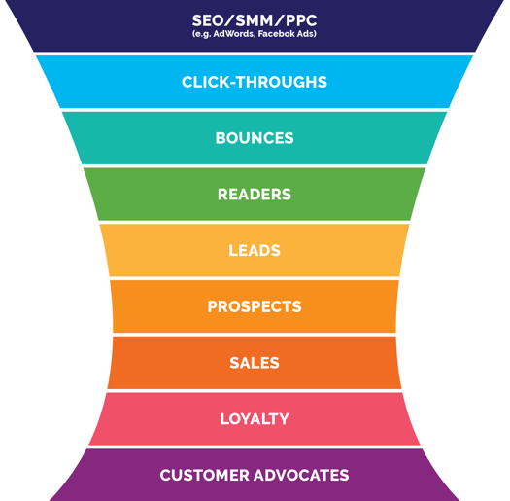

TOP FUNNEL  (TOFU) | 100,000 | Reach, Ad Impressions, Keyword Searches
TOP FUNNEL  (TOFU) | 10,000 (1% CTR) | Visitors, Page Views (landing page/website)
MIDDLE FUNNEL (MOFU) | -5,000 (50% bounce rate) | Percentage which immediately leaves
MIDDLE FUNNEL (MOFU) | =5,000 readers | Content Readers
MIDDLE FUNNEL (MOFU) | 1,000 leads (10% of readers) | Leads  (opt-in via form)
BOTTOM FUNNEL  (BOFU) | 500 prospects (20% of leads) | Prospects (respond to email call to actions)
BOTTOM FUNNEL  (BOFU) | 3 sales conversions (20%) | Customers  (i.e. actual sales)
BOTTOM FUNNEL  (BOFU) | 40 repeats (40% of customers) | Loyal Customers
BOTTOM FUNNEL  (BOFU) | 33 advocates (300% of customers) | Advocates

Social Media

To prepare for this digital marketing strategy, we conducted a social media audit. The audit found: (edit as per my feedback on your social media audit)

- [Good/average/poor engagement] rates on social networks
- Channel strategies for each platform required
- We need a content plan including repurposing
- More video content recommended
- Social media management platform recommended
- Monthly metrics needs to be reviewed

Social Media Metrics Benchmark
We conducted a 28-day review of our social media activity from a typical month [insert month] and this provides our benchmark metrics i.e. where we are now and how we can improve to meet our goals and KPIs.

Channel | 28-Day Metrics | Comments / Recommendations
Facebook | XX followers  X posts per day / X total posts  X engagement rate  Total number of reactions
Instagram | XX followers  X posts per day / X total posts  X engagement rate  Total number of reactions
Twitter | XX followers  X Tweets per day / X Tweets  X engagement rate  Total number of reactions

Website Marketing

On-Page SEO
Audit existing website and mark any actions that need to be completed and document by whom. Please note this technical on-page SEO should and can be completed by your webmaster (the person responsible for the day-to-day management of your website).

Audit | Current Data | Action (Who?) | Target
Google Webmaster Tools –  Crawl Errors (how many) |  |  | 0
XML sitemap submitted

Number of pages indexed vs submitted should be similar (unless you deliberately block some pages from indexing
Google Webmaster Tools – Data Highlighter (is it being used to mark-up relevant data)
Google Webmaster Tools –
HTML Improvements
On-Page SEO - % of pages in top 3
Page Speed (use Google Page Speed Insight) |  |  | 80+ on both mobile and desktop
Google Webmaster Tools –
Links to your website
Domain Authority www.opensiteexplorer.org
Duplicate Content (SERPs do not like this) www.copyscape.com and www.siteliner.com
Domain redirect – does domain.ie redirect to www.domain.ie
URLs (should show website hierarchy and exclude
?&=%)
Breadcrumb navigation (is it present and correct)
Google Local Listing www.google.com/business
Other local directories listings (ensure NAP details are the same on all sites including Google)
Custom 404 error page – have you one and where does it lead customers
Responsive website – is your website mobile ready
/ responsive (include all booking elements)

Off-Page SEO
Off pages SEO takes your inbound links into account - the quantity and quality of them. This part of your SEO plan ties in directly with your content marketing plan. To create quality content for your users that they want to share, endorse, engage with and link to. See below for more on content marketing.

 | You | Competitor 1 | Competitor 2 | Competitor 3
Domain Authority www.opensiteexplorer
.org
MozTrust
MozRank
Follow Linking Route Domains
Total Links
Social Sharing

Based on the data above – set actions and targets. Are there any opportunities that you are missing? Are your competitors listed on websites you could be listed on? Are there are bloggers you could reach out to share and engage with your blog content? Create a plan for how you will increase the amount and quality of your inbound links.

[Add in details here]

Google Analytics
The 28-day view of our website metrics below provide a benchmark of an average month of activity.

Sessions
Unique Users
Sessions per user
Pages per session
Pageviews
Average session duration
Bounce rate
Acquisition
Demographics
Device
Location
Top Pages
Top 10 Keywords

Content Planning

Content planning forms the central cog in our digital marketing wheel. Our content plan serves our key audiences across a range of digital channels. We need to have four key content calendars to serve our audiences online.

Each calendar has its own remit as follows:

Content Planning (edit accordingly to your own organisation)
- Quarterly content planning for each audience/topic
- Sub-Topics: Discuss what content topics we will cover in the next quarter
- Example: 2021 Walking Tours on the Wild Atlantic Way
- Long-form content repurposed for social media – so we create one of the following pieces of content first before using it for social:
- Video
- Podcast
- Article / blog post / report / press release

Quarterly Plan (edit accordingly to your own organisation)
Long-form content repurposed for social media

- 12 x blog posts: 1 per week / 6 subject matter experts / 2 posts per person
- 3 x webinars: 1 per month / 3 subject matter experts / 1 per person
- 12 x podcasts (launching Q1 2021): Series-based / weekly episodes (batch produced)
- 3 x Op Ed: Written by CEO/business owner / 1 per month
- 6 x E-zines: Bi-monthly / first and third Tuesday of the month
- 6 x LinkedIn articles: Two per week / 6 subject matter experts / 1 per person
- 60 x Tweets: 1 original Tweet per day (Monday to Friday) repurposed from long-form content / plus Quote Tweets / replies / likes
- 36 x Facebook Posts: 3 per week / repurposed from long-form content
- 36 x Instagram Posts: 3 per week / repurposed from long-form content
- 3 x Facebook Ad campaigns: 1 per month / targeted by audience & topic

Sample Quarterly Plan (edit accordingly to your own organisation)

Q1 | Audience | Content Type | Topic | Platform/s
 | Persona #1 | Video |  | YouTube  Website  IGTV  Facebook  E-zine
 | Persona #2 | Webinar |  | Zoom  Facebook Watch  YouTube
 | Persona #3 | Blog |  | Website  LinkedIn Article/Post  Twitter  E-zine
 | Persona #4 | Twitter Chat |  | Twitter  Blog
 | Persona #5 | Poll |  | Instagram  LinkedIn  Twitter

Monthly Content Calendar
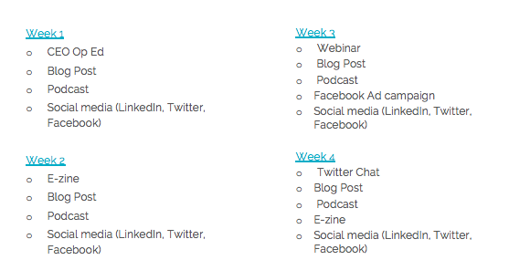

Weekly Content Calendar
- Facebook: Monday, Wednesday, Friday
- Instagram: Monday, Wednesday, Friday
- Twitter: Monday, Tuesday, Wednesday, Thursday, Friday
- LinkedIn: Monday, Wednesday, Friday
- YouTube: Weekly interview/ monthly series

Channel Strategies
Channel | Feature | Frequency
LinkedIn | CEO Opinion Editorial Article | Monthly
Twitter | Twitter Chat | Monthly
Facebook | Livestream  Stories | Monthly
Instagram | Livestream  Stories | Monthly
Facebook Ads | Campaign | Monthly

Community Management

In order to manage the interaction with [the public/our customers] we will introduce new protocols as follows:
- Set aside 10-minutes per day to respond to queries on all channels
- Have a live Google doc to add FAQ information / frequent nasty comments for new content creation ideas
- Crowdsource your community monthly for topic / questions

PPC advertising (Google and Facebook/Instagram)

Google AdWords is a proven method of driving quality leads to your website.
As part of our digital plan, it is envisaged that we may will run regular campaigns for specific promotions e.g. walk the Wild Atlantic Way.

- Search Ads: this will be the main method of driving traffic to the site and the core aim is to [fill in]
- Remarketing: This is where we run PPC ads across Google’s Display Network to people who have visited our website. These will be image ads and the core aim for these ads are [fill in] image ads will be created using the [display ad builder OR designers].

Budgets and Targets
Medium | Daily/Monthly Budget | CTR | Conv. Rate | Mgt. Costs | ROI  (need ad to start running to gauge cost)
AdWords |  | 5%-7%
Remarketing |  | 0.5%
Total per month
Total Year 1

Facebook Ads Planner
Facebook is an excellent platform to reach specific audiences and it is envisaged that we will run ads on Facebook promoting specific promotions.

Type of Ad (boost or ad) | Budget | Persona Target Group | Location | Promotion / Content | Goal
Boost |  |  |  | Campaign CTA | e.g. Increase likes by 10%, brand awareness and increase email marketing data base – 50% of all entrants to sign up for emails
Ad (desktop and mobile newsfeed) |  |  |  | FREE places | CTR: (average is 2.09% on newsfeed)  Leads:  Increase email marketing database:
Video ad

Facebook ads CTR and Conversion rates will depend on the ad goals. Each campaign can have the CTR and conversion rates targets defined once they are decided on.

List Building and Email Marketing

Email marketing is still one of the most cost-effective ways of generating leads and sales. The key to a successful campaign is in the following areas:

- Personalisation –
  - Capturing names and using it in the subject and at the beginning of the
Email e.g. Dear [Joanne]….
  - Sending it from a person rather than the organisation e.g., from Mary Smith
  - Branding – ensuring that the template is well branded.

- Subject line – ensuring it is interesting, short and relevant.

- Segmented lists – this ensures that each recipient receives information that is relevant to them (and which they signed up for) which ensures a higher ROI (return on investment).

- Regular intervals – sending e-zines at regular intervals.

- Being useful – sharing information that is useful is a great way to ensuring a high open rate (look at the content we are creating under the content marketing plan and share this with your email recipients).

- Analysing reports – it is important to continually learn from your database. Review what people open, read and engage with. This will allow us to send effective emails that have

Targets:
Open rate: [15%] Benchmarks can be found here: https://mailchimp.com/resources/

Click through rate: [5%]

Leads: [2%]

Plan: To send monthly e-zine [date each month – dates, days of week, times sent should be tested]

Information to be include in e-zine: [fill in]
Example:
- Recent Blog
- Top tip for your audience
- Events
- Campaigns
- Competitions
- Breaking news
- Industry trends

Marketing Automation & Scalability

In order to meet the goals in this 18-month plan, we will have to streamline our marketing and communications process.

There are three core steps we will take:

In order to scale and streamline our digital marketing communications we are going to invest in software. Below are recommended tools to support the implementation of this plan.

 | AgoraPulse  An easy-to-use social media management software that allows you to drive engagement and build authentic relationships on one platform.  Cost: From US$79.00 per month (billed annually)
 | Streamyard  A live streaming studio in your browser. Interview guests share your screen, and more.  Cost: From FREE to US$39.00 per month (billed annually)
 | Zoom  An easy, reliable cloud platform for video and audio conferencing, chat, and webinars.  Cost: From FREE to US$19.99 per month/host
 | InVideo  A video creation platform that helps you to transform your content into great videos to expand audience engagement.  Cost: From US$20.00 per month
 | Vyond  A cloud-based, animated video creation platform that allows people of all skill levels in all industries and job roles to create dynamic and powerful media.  Cost: From US$49.00 per month
 | Captivate  An easy-to-use podcast hosting provider.  Cost: From US$19.00 per month (Free trial available)
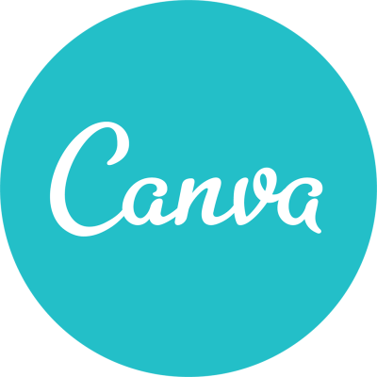 | Canva  A drag-and-drop graphic design tool that allows users to create social media graphics, presentations, posters and other visual content  Cost: From FREE to US$30.00 per month (billed annually)
 | Tweet Binder  A social media monitoring tool. It allows you to generate reports and track hashtags on Twitter and Instagram.  Cost: From US$40.00 per month
 | Splasheo  Video creation tool for creating videos with catchy captions and headlines.  Cost: From US$89.00 per month (billed annually)
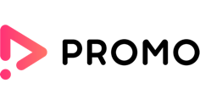 | Promo  Marketing video creation tool with a host of high-quality stock photos, video footage and pre-made templates.  Cost: From US$39.00 per month (billed annually)
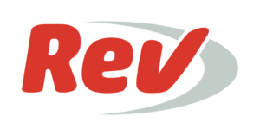 | Rev  An online audio transcription and video caption services.  Cost: US$1.25 per audio minute

Metrics and Results
We have identified which digital metrics we will measure in our monthly, quarterly and annual reports as a way of analysing KPIs.

- Weekly – review top content, high-level metrics, KPIs
- Monthly – export AgoraPulse cross channel performance account
- Quarterly – deep dive into trends/opportunities
- Annual – audit and recommendations
- Campaign – hashtag, content, reach, engagement, video views
- Advertising – cost per result, reach, engagement, video views, relevance score, click-through-rate

Social Media | Email Marketing | Website | Video | Hashtag / Twitter Chat | Podcasts | Webinars/Livestreams
- Followers / connections / subscribers  - Reach / impressions  - Engagement Rate  - Post Interaction  - Total comments, likes, shares  - Growth  - Video views  - Top performing content  - Facebook Ad value (Facebook only)  - Profile views | - Device: mobile, tablet, desktop  - Open rate: how many people opened as a % of total emails sent  - Click-through rate: % of people that clicked on links & number of links clicked in an email  - Number of new subscribers / un-subscribers  - List total: growth month-on-month  - Bounce rate: % that didn’t deliver | - Sessions  - Users  - Sessions per user  - Pageviews  - Pages per session  - Dwell time  - New V returning  - Gender, age location  - Top pages viewed  - Device  - Bounce rate | - Total videos  - Video views  - View through rate  - Livestream views  - Replay of livestream views  - Likes, comments, shares  - Top video content | - Trending position  - Reach / impressions  - Top influencers  - Top accounts  - Total Tweets  - Top Tweets  - Top Media Tweet | - Subscribers  - Downloads  - Total listens  - Ratings  - Reviews  - No of episodes | - Subscribers  - Live participants  - No of webinars  - Topic  - Feedback

Strategy Sign-Off and Iteration

This strategy is a live document and will be reviewed on a weekly basis as a roadmap for implementation.

While it will guide us for 18-months we will update it in real-time to reflect changes in our business/organisation.

Signed

NAME

Date

