Digital Marketing Funnel Template

TOP FUNNEL  (TOFU) | 100,000 | Reach, Ad Impressions, Keyword Searches | 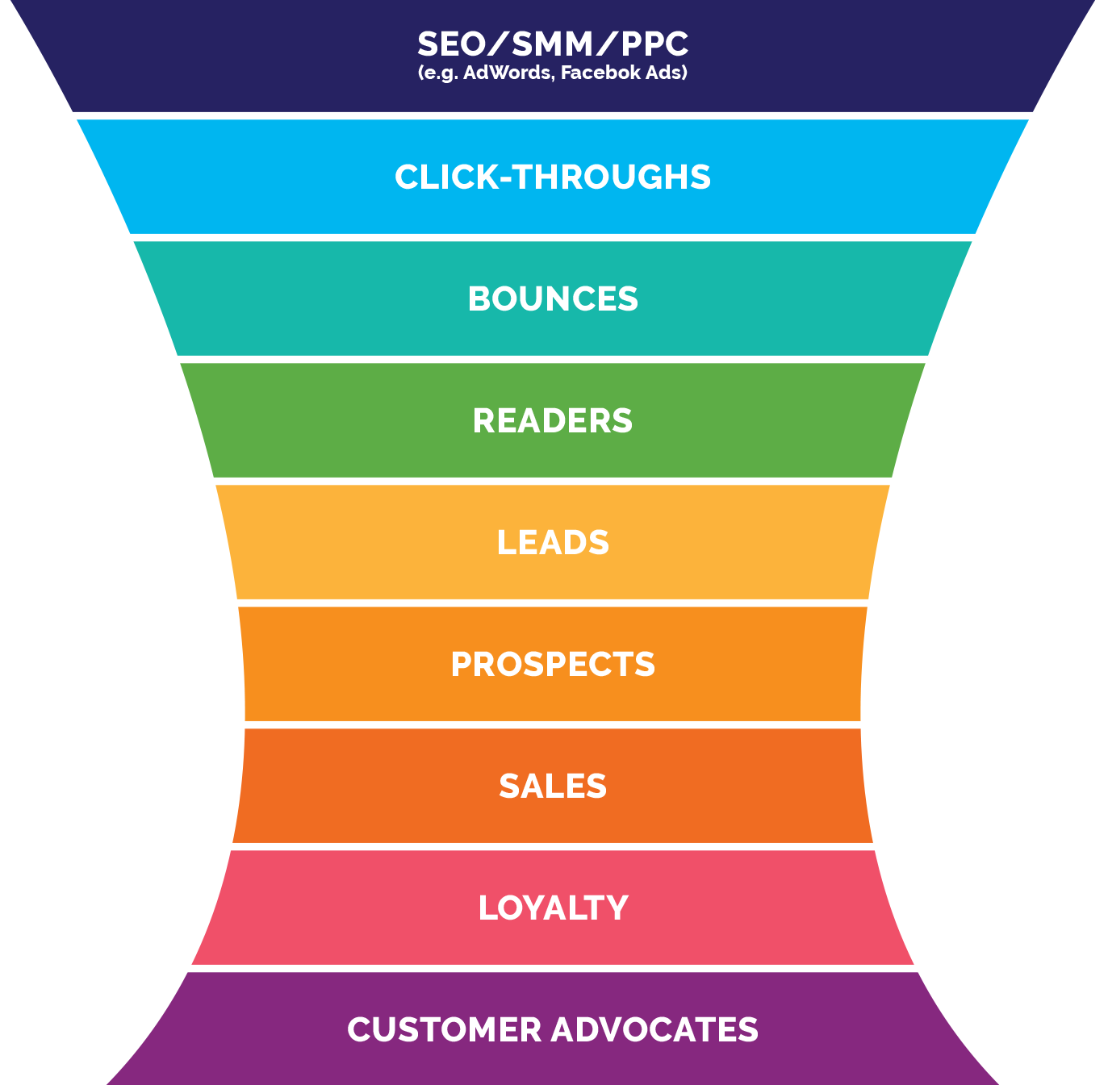
TOP FUNNEL  (TOFU) | 10,000 (10% CTR) | Visitors, Page Views (landing page/website)
MIDDLE FUNNEL (MOFU) | -5,000 (50% bounce rate) | Percentage which immediately leaves
MIDDLE FUNNEL (MOFU) | =5,000 readers | Content Readers
MIDDLE FUNNEL (MOFU) | 1,000 leads (20% of readers) | Leads  (opt-in via form)
BOTTOM FUNNEL  (BOFU) | 500 prospects (50% of leads) | Prospects (respond to email call to actions)
BOTTOM FUNNEL  (BOFU) | 100 sales conversions (20%) | Customers  (i.e. actual sales)
BOTTOM FUNNEL  (BOFU) | 40 repeats (40% of customers) | Loyal Customers
BOTTOM FUNNEL  (BOFU) | 33 advocates (300% of customers) | Advocates

